EXERCISE 1: CONFIGURING A BASIC STIRNG APPLICATION

Scenario:
Your company is developing a web application for managing a library. You need to use the Spring Framework to handle the backend operations.

MainApp.java:
package com.library;

import com.library.service.BookService;
import org.springframework.context.ApplicationContext;
import org.springframework.context.support.ClassPathXmlApplicationContext;

public class MainApp {
public static void main(String[] args) {
ApplicationContext context = new ClassPathXmlApplicationContext("applicationContext.xml");
BookService bookService = (BookService) context.getBean("bookService");
bookService.showBooks();
}
}
BookRepository.java:
package com.library.repository;

public class BookRepository {
public void displayBooks() {
System.out.println("Displaying all books from the repository.");
}
}
pom.xml(Library Management):
<project xmlns="http://maven.apache.org/POM/4.0.0"
xmlns:xsi="http://www.w3.org/2001/XMLSchema-instance"
xsi:schemaLocation="http://maven.apache.org/POM/4.0.0
http://maven.apache.org/xsd/maven-4.0.0.xsd">
<modelVersion>4.0.0</modelVersion>
<groupId>com.library</groupId>
<artifactId>LibraryManagement</artifactId>
<version>1.0-SNAPSHOT</version>
<dependencies>
<dependency>
<groupId>org.springframework</groupId>
<artifactId>spring-context</artifactId>
<version>5.3.20</version>
</dependency>
</dependencies>
</project>

OUTPUT:
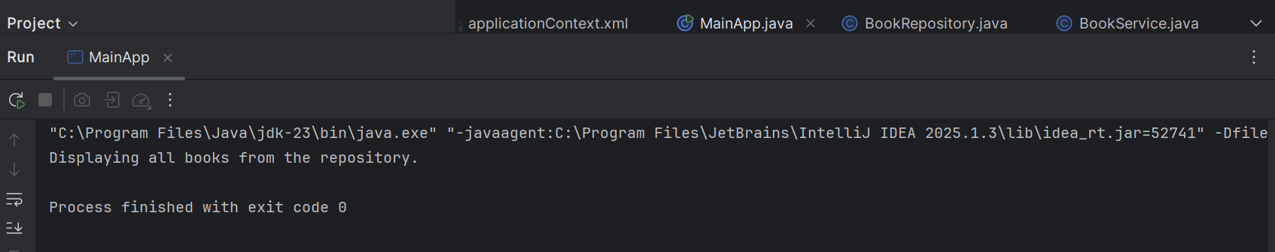

EXERCISE 2: IMPLEMENTING THE DEPENDENCY INJECTION

Scenario:
In the library management application, you need to manage the dependencies between the BookService and BookRepository classes using Spring's IoC and DI.

LibraryManagementApplication.java:

package com.example.library;

import org.springframework.context.ApplicationContext;
import org.springframework.context.support.ClassPathXmlApplicationContext;

public class LibraryManagementApplication {
public static void main(String[] args) {
ApplicationContext context =
new ClassPathXmlApplicationContext("applicationContext.xml");

BookService bookService = context.getBean("bookService", BookService.class);
bookService.performService();
}
}
BookRepository.java:

package com.example.library;
public class BookRepository {
public void printRepository() {
System.out.println("BookRepository: Accessing books...");
}
}
BookService.java:
package com.example.library;

public class BookService {
private BookRepository bookRepository;

// Setter method for dependency injection
public void setBookRepository(BookRepository bookRepository) {
this.bookRepository = bookRepository;
}

public void performService() {
System.out.println("BookService: Performing service...");
bookRepository.printRepository();
}
}
pom.xml(Library Management):

<project xmlns="http://maven.apache.org/POM/4.0.0"
xmlns:xsi="http://www.w3.org/2001/XMLSchema-instance"
xsi:schemaLocation="http://maven.apache.org/POM/4.0.0
http://maven.apache.org/xsd/maven-4.0.0.xsd">
<modelVersion>4.0.0</modelVersion>

<groupId>com.example</groupId>
<artifactId>LibraryManagement</artifactId>
<version>1.0-SNAPSHOT</version>

<dependencies>
<dependency>
<groupId>org.springframework</groupId>
<artifactId>spring-context</artifactId>
<version>5.3.30</version>
</dependency>
</dependencies>
</project>
OUTPUT:
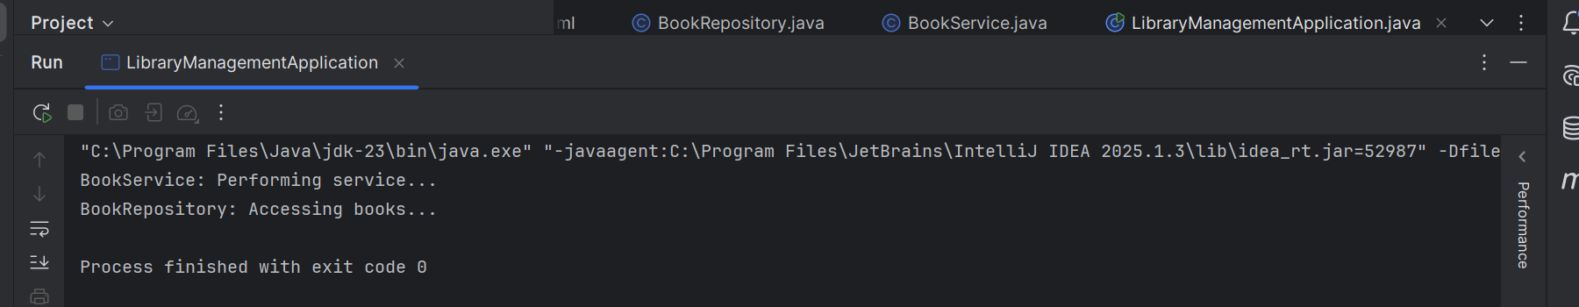

EXERCISE 3: CREATING AND CONFIGURING A MAVEN PROJECT

Scenario:
You need to set up a new Maven project for the library management application and add Spring dependencies.

App.java:
package com.example.library;

public class App {
public static void main(String[] args) {
System.out.println("Library Management Project Running...");
}
}
Pom.xml(Library Management):
<project xmlns="http://maven.apache.org/POM/4.0.0"
xmlns:xsi="http://www.w3.org/2001/XMLSchema-instance"
xsi:schemaLocation="http://maven.apache.org/POM/4.0.0 http://maven.apache.org/xsd/maven-4.0.0.xsd">
<modelVersion>4.0.0</modelVersion>

<groupId>com.example.library</groupId>
<artifactId>LibraryManagement</artifactId>
<version>1.0-SNAPSHOT</version>
<packaging>pom</packaging>
<modules>
<module>src</module>
</modules>

<dependencies>
<dependency>
<groupId>org.springframework</groupId>
<artifactId>spring-context</artifactId>
<version>5.3.33</version>
</dependency>
<dependency>
<groupId>org.springframework</groupId>
<artifactId>spring-aop</artifactId>
<version>5.3.33</version>
</dependency>
<dependency>
<groupId>org.springframework</groupId>
<artifactId>spring-webmvc</artifactId>
<version>5.3.33</version>
</dependency>
</dependencies>
<build>
<plugins>
<plugin>
<groupId>org.apache.maven.plugins</groupId>
<artifactId>maven-compiler-plugin</artifactId>
<version>3.8.1</version>
<configuration>
<source>1.8</source>
<target>1.8</target>
</configuration>
</plugin>
</plugins>
</build>
</project>
OUTPUT:
